Pentecostal Faith Assemblies
Camp Meeting
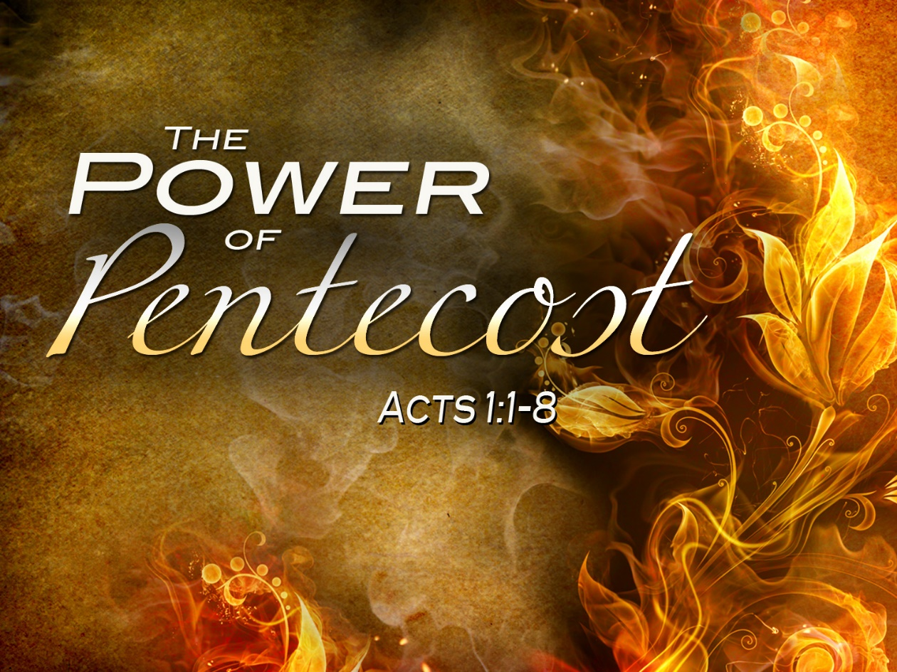
July 15 – 17, 2022
Hosted by
River of Life Pentecostal Church
510 Colonial Ave.
Colonial Beach, VA 22443
(804) 224-8157

Service Schedule
Friday 10 am, 11 am, 6 pm
Saturday 11 am PFBC graduation, 6 pm
Sunday 10 am and 11 am

Lunch provided daily.

Accommodations
There are several hotels, B & Bs, cottages and RV/camping facilities in the area which can be found online.

